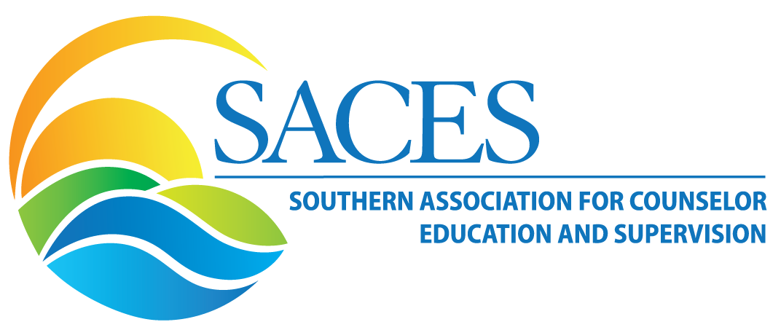
VOLUME 16, ISSUE 1

IN THIS ISSUE

President’s Message 1

2019-2020 SACES Leadership 3

Meet the New Co-Editor 5
Cultivating Leadership and Connection Through Relational Mentorship 6
Meeting the Call to Action: Addressing Disability Competence During COVID-19 8
Clinical Mental Health Interest Network 11

Service-Learning in Counselor Education: Enhancing Personal and Professional Development through Classroom, Community and Service Connections 12

The Graduate Student and New Professionals Interest Network 15

Fall 2020 Newsletter Submissions 15

Cohort Support and Professional Identity Development for First-Year Doctoral Students during 16

Distance/Online Learning Interest
Networks 17

Social Justice and Human Rights Interest Network 18

FROM THE PRESIDENT
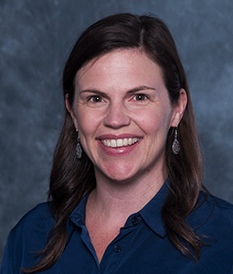

Dear SACES members!

I am honored and excited to serve as the 2020-2021 SACES President. My hope is that we are beginning a year of change within our profession specifically related to challenging the status quo of counselor education and counseling as it relates to individual and systematic racism and white superiority. I hope that the change is beyond words and that we are action-orientated in the ways we are being anti-racist in our pedagogy, research, supervision, programs, universities, counseling offices, and most importantly as humans. Currently, there is an open call for a special issue of Teaching and Supervision in Counseling focused on Anti-Racist Counselor Education. I am grateful that guest editors Drs. Paul C. Harris, Erik M. Hines, and Renae D. Mayes, along with the TSC editor Dr. Kelly Wester and the associate editor Dr. Bradley McKibben have offered their time to provide a resource to SACES members and beyond that challenge professionals for change and provide action steps. They are encouraging submissions of a 3 page proposal to tscjournal@saces.org by September 11, 2020 and an invitation to submit will be provided to authors by the guest editors by September 25, 2020, and the tentative publication date will be June 2021.

As we are all aware, the 2020 SACES conference in Baltimore has been cancelled. Therefore, the SACES Executive Committee and the SACES Webinar Committee are collaborating to provide a new set of learning experiences through the SACES Virtual Professional Development Series. Save the date for the following webinar topics for the fall: October 15th 3-4pm ET, Telemental Health Counseling and Supervision; November 19th 3-4pm ET, Virtual School Counseling; and December 10th 3-4pm ET, Grant Writing. Additionally, there will be a SACES Presidential sponsored panel presentation, on September 24th 2:30-4:00pm eastern time, with three prominent higher education and counselor education leaders, who are also all SACES members: Dr. Kent Butler, UCF’s Interim Chief Equity, Inclusion and Diversity Officer and President-Elect of ACA; Dr. Andrew Daire, Dean of the VCU School of Education; and Dr. Grant Hayes Interim Provost and Vice Chancellor of ECU. The focus of the panel will be antiracist leadership within counselor education; the panel will be moderated by Dr. Marlon Johnson. We will still have the SACES Emerging Leaders program, SACES research grants and awards, SACES graduate student meeting, and will host a virtual fall SACES business meeting. I would like to extend a special thank you to the SACES webinar committee co-chairs Drs. Mickey White, Nancy Thacker, and Janelle Cox and Dr. Jessie Guest, the virtual series coordinator, for all of their work planning the SACES Virtual Professional Development Series. If you have questions about the series, please contact me or the co-chairs at webinars@saces.org

The focus of this newsletter is community, and I feel fortunate to be a part of the SACES community. I would like to extend a personal thank you to four SACES leaders who are unfortunately no longer on the SACES Executive Committee: Drs. Cheryl Wolf, Natoya Haskins, Hannah Coyt, and Caitlyn Bennett. All four women have made a lasting mark on SACES, and I’m grateful for their service to SACES members. I’m also thankful for current leadership, Drs. Elizabeth Villares (past-president), Sejal Barden (president-elect), Brandee Appling (secretary), Mario De La Garza (treasurer), Galaxina Wright (graduate student representative) and Shelby Gonzales (graduate student representative designee). Additionally, all 2020-2021 SACES committee and interest network chairs have been appointed and I appreciate all the hard work that they have already started. I encourage you to get involved with a committee and/or interest network.

I recognize that this academic year is going to be unlike any other that we have experienced, but I don’t think all the change will be negative. I know that the SACES Executive Committee is committed to supporting the SACES members however we can. My approach to the year as the President of SACES, as a faculty member, and in my personal roles will be to have grace, flexibility, and do my best and believe that everyone else is doing the same. I encourage you to be action-oriented and get involved and help make a difference. Please don’t hesitate to contact me at president@saces.org

Sincerely,

Dodie Limberg
2020-2021 SACES President

2020 – 2021 SACES LEADERSHIP

EXECUTIVE COUNCIL
Past-President Elizabeth Villares Florida Atlantic University
President Dodie Limberg University of South Carolina
President-Elect Sejal Barden University of Central Florida
Secretary Brandee Appling University of Georgia
Treasurer Maria De La Graza Southern Methodist University
Graduate Student Rep. Galaxina Wright University of Central Florida
Graduate Student Rep. D Shelby Gonzales University of South Carolina
COMMITTEE CHAIRS
Awards Ken Shell Clark Atlanta University
Lacey Ricks University of West Georgia
Regina Finan University of Georgia
Budget & Finance Mario De La Garza Southern Methodist University
Bylaws & Resolutions Elizabeth Villares Florida Atlantic University
Conference Dodie Limberg University of South Carolina
Graduate Student Galaxina Wright University of Central Florida
Hannah Coyt Lindsey Wilson College
Emerging Leaders Elizabeth Villares Florida Atlantic University
Social Media Janelle Jones The University of Alabama
Adrianne Robertson Georgia State University
Membership Bre’Ana Parker The University of Georgia
Hannah Bowers Florida Atlantic University
Nominations & Elections Elizabeth Villares Florida Atlantic University
Research & Practice Grants Elizabeth Villares Florida Atlantic University
Newsletter Co-Editors Isabel Farrell Wake Forest University
Andrea Kirk-Jenkins Western Kentucky University
Webmaster Esther McCartney University of South Carolina

SPECIAL COMMITTEES
Webinars Mickey White East Tennessee State University
Nancy Thacker Auburn University
Journal Editor Kelly Wester University of North Carolina, Greensboro
Journal Associate Editor Bradley McKibben Nova Southeastern University
Publications Casey Barrio Minton University of Tennessee, Knoxville

SPECIAL INTEREST NETWORKS

Clinical Mental Health Counseling Jessie Guest University of South Carolina
Genee` Glascoe University of South Carolina
College Counseling & Student Affairs Chris Pisarik University of North Georgia
Kristian Robinson Virginia Commonwealth University
Distance/Online Counselor Education Ellen Chance Capella University
Summer Kuba Liberty University
Ethics & Professional Development Anthony Veja University of Arkansas
Brooke Wymer Clemson University
International Counseling Ashlei Rabess Georgia State University
Nicole Silverio University of NC Greensboro
Multicultural Counseling Sarah Bran-Rajahn Messiah University
Donya Wallace Palo Alto University
School Counseling Christy Land University of West Georgia
Service Learning Breahannah Hilaire University of Central Florida
Jordan Wescott Virginia Tech
Social Justice and Human Rights Marlon Johnson Seminary of the Southwest
Mickey White East Tennessee State University
Supervision Kenya Bledsoe University of Mississippi
Monica Lepma University of West Virginia
Women's Caroline Perjessy National Lewis University
Noelle St. Germain-Sehr College of William & Mary
Technology Frankie Frachilla Trevecca Nazarene University
Angie O'Gieblyn Lynn University.

Meet the New Co-Editor
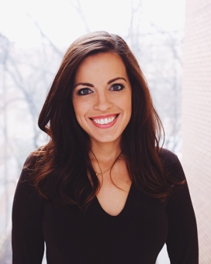
We welcome a new co-editor to our team, Dr. Isabel Farrell. Dr. Isabel Farrell holds a doctoral degree in counselor education, is a National Certified Counselor, and is a Licensed Professional Counselor. An assistant professor of counseling at Wake Forest University, Dr. Farrell holds special interests in bilingual counseling, counseling with Spanish-speaking immigrants, legislative advocacy, and work with undocumented clients. Dr. Farrell is the 2017 past recipient of the Outstanding Counseling Advocate of the Year awarded by the Smoky Mountain Counseling Association, 2016 National Board for Certified Counselors (NBCC) Minority Fellow, and 2018-2019 Chi Sigma Iota Intern. During her time as a. 2018-2019 Chi Sigma Iota Intern, she was the Intern editor for The Exemplar.

We thank Dr. Andrea Kirk-Jenkins for her continued leadership and service for an additional year as co-editor.
In addition, we would like to thank Dr. Brandee Appling for her leadership and service as the SACES Newsletter co-editor for the past three years, her contributions have been invaluable.

“As my tenure as SACES newsletter co-editor comes to a close I would like to thank the current and past presidents for such a positive experience and all your hard work and dedication in making the newsletter a meaningful resource for our membership. In addition, a special thanks to my co-editor Dr. Andrea Jenkins for helping to make this such a successful partnership over the last three years. To our past newsletter graduate assistants, Mary Cullen Servodidio and Anastasia Atchley thank you for all your hard work and assistance.” Dr. Appling

SACES September Webinar: Toward Antiracist and Feminist Pedagogy in Counselor Education
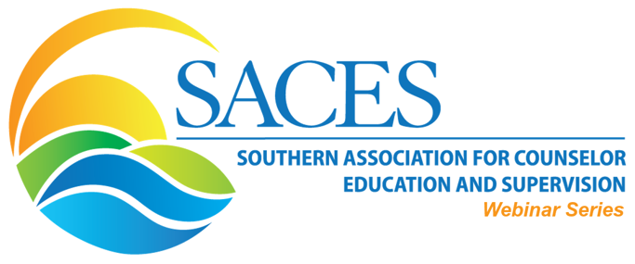
Who: Dr. Allison Levine (she/her/hers), CRC, LPCA & Dr. Travis Andrews (he/him/his), LCMHC-S, CRC, BC-TMH
1 CE available. Recording available on the SACES Website.
Description: Recent outcries for racial justice amplify the importance of elevating antiracist pedagogies and competencies of counselor educators. Although there have been decades of calls to improve multicultural competence in counselor education (e.g., AMCD's Multicultural Competencies, 1996), White counselor educators still report significantly less knowledge of multicultural competencies than non-White educators (Barden et al., 2016). Understanding antiracist and feminist pedagogies and approaches will help counselor educators to provide support for their students from historically marginalized groups, to develop competency in problematizing hegemonic narratives, and ultimately improve student multicultural competence.
Questions about the SACES webinar series? Visit saces.org/webinars or contact the SACES Webinar Committee Chair at SACESwebinars@gmail.com.

Cultivating Leadership and Connection Through Relational Mentorship
Carrie Elder, MS, LPC, ATR-BC, CPCS and Elizabeth K. Norris, MA, LPC, NCC, BC-TMH, Mercer University. Leann M. Morgan, PhD, LPC, CCCE, Walden University
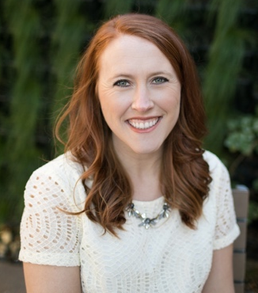
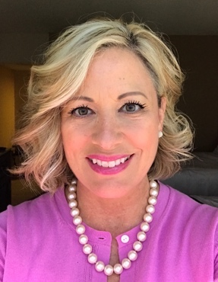
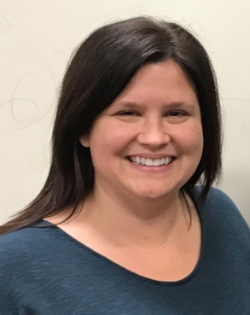
Carrie Elder (left), Elizabeth K. Norris (middle), and Leann M. Morgan (right)

Influential leadership and service within the counseling profession does not always necessitate obtaining formal positions within a counseling organization or association. While these positions are crucial to the evolution of the profession, more accessible forms of cultivating connection and community through mentorship are widely available and beneficial for both seasoned counselor educators and counselor education doctoral students. During the isolative nature of COVID-19 shelter-in-place restrictions, connecting through mentorship may provide an avenue for the continued development of counselor educator identity, leadership, and community.

Mentorship takes many different forms and serves different purposes over the course of counselor educators’ careers. In a study of ACA past-presidents, receiving mentorship was found to be a common phenomenon, impacting leader development (Gibson et al., 2018). Counselor education students tend to receive mentorship from core faculty and through required supervision from onsite supervisors during their fieldwork courses, which mainly focuses on a teaching-style of mentoring (Lazovsky & Shimoni, 2007). In an ideal situation, counselor education doctoral students would engage in a more egalitarian mentorship relationship with counselor educators from outside of their own college or university, which may provide an important next step in their overall leader development.

Most academic mentoring (i.e. student teaching, research assistant positions) occurs within the necessary boundaries of a professional relationship and tends to be hierarchical where one member is able to offer a greater breadth and depth of knowledge than the other (Fletcher & Ragins, 2007). Mentorship outside of a student’s home institution may have more flexibility and carry fewer expectations, thus making room for a collective, Relational Cultural Theory (RTC) approach to support the relationship. In this model, mentor and mentee grow in connection with one another, as well as derive mutual benefit from their work together (Jordan, 2004). Through the purposeful lens of RCT, all participants contribute to group and individual growth. Additionally, it allows for both personal and professional engagement and relationship development on a mutually respectful platform. This form of personal and professional mentoring is an invaluable resource for creating connection, community, and in modeling leadership that may extend into the profession.

Making connections with a variety of counselor educators is an important step in finding adequate support for the next phase of a doctoral student’s professional development. This can be accomplished through intentional networking efforts. Admittingly, networking may not come naturally to all doctoral students. Fortunately, it is a professional social skill that can be cultivated through practice. Some of the first steps of networking for the purposes of exploring mentoring relationships may include researching conference presenters with common research agendas and greeting them after a presentation or e-mailing authors from published manuscripts that were of interest. It is possible that from these efforts, trusting and mutually beneficial relationships, as described in the RCT approach, can be formed.

Professional mentoring relationships have the potential to provide meaningful connections and serve as a necessary steppingstone in both the students’ and the seasoned faculty member’s development. In this way, students are challenged to be forward thinkers, develop new ideas, adopt new roles, and authentically address “mess-ups” in a safe environment. Through collaborative relationships, mentees can practice leadership skills, develop research agendas, and explore additional pedagogical and supervision methods from other points of view with more autonomy while still receiving additional support as a student.

Students may also increase their opportunities by seeking outside mentorship, in addition to that of their core faculty, while exploring their needs in a mentor and the overall goodness of fit (Baltrinic at al., 2018). Additionally, since the relationship is bidirectional, mentors must be active participants in the relationship instead of giving advice (Rheineck & Roland, 2008). This step of counselor educator development can be easily overlooked yet seems to be an important step in transitioning from a counselor educator trainee to an independent counselor educator. Students’ home institution provides a solid foundation developmentally appropriate for their stage in the doctoral process. Outside mentoring can create an environment of authenticity, serving as a container that is supportive, safe, and personal where students are encouraged to reach beyond their current comfort level to increase confidence.

As a mentor, a seasoned counselor educator is still in the position to enhance one’s own leadership and service skills while staying current by investing in what doctoral students bring to the table. There is a sense of empowerment that results from positive, impactful mentorship, that also aligns with the RCT perspective, where the creation of symbiosis is a collective experience. Mentors bring their whole self to the group, and mentees develop their skills as mentors to others, hence mentors beget mentors. Good mentorship creates other capable mentors and leaders throughout the counselor education community as we look toward the next evolution of the profession in our post-COVID world.

References

Baltrinic, E. R., Moate, R. M., Hinkle, M. G.,
Jencius, M., & Taylor, J. Z. (2018). Counselor educators’ teaching mentorship styles: A Q methodology study. The Professional Counselor, 8, 46-59.
Fletcher, J. K., & Ragins, B. R. (2007). Stone
Center Relational Cultural Theory: A window on relational mentoring. In B. R. Ragins & K. E. Kram (Eds.), Handbook of mentoring at work: Theory, research, and practice (pp. 373–399). Thousand Oaks, CA: Sage.
Gibson, D. M., Dollarhide, C. T., Moss, J. M., Aras,
Y., and Mitchell, T. (2018). Examining leadership with American Counseling Association Presidents: A grounded theory of leadership identity development. Journal of Counseling & Development, 96, 361-371.
Jordan, J. V. (2004). Relational awareness:
Transforming disconnection. In J.V. Jordan, M. Walker, & L. M. Hartling (Eds.), The complexity of connection: Writings from the Stone Center’s Jean Baker Miller Training Institute (pp. 47–63). New York, NY: The Guilford Press.
Lazovsky, R. & Shimoni, A. (2007). The on-site
mentor of counseling interns: Perceptions of ideal role and actual role performance. Journal of Counseling & Development, 85, 303-316.
Rheineck, J. E., & Roland, C. B. (2008). The
developmental mentoring relationship between academic women. Adultspan Journal, 7, 80–93.

Meeting the Call to Action: Addressing Disability Competence During COVID-19
Kristina Henderson, PhD, LPC, CRC, CPCS and Jabari Strozier, MS, CRC, NCC, Mercer University

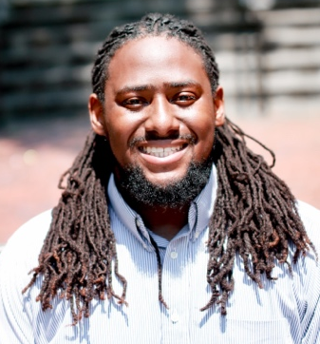
Kristina Henderson (Left)
and Jabari Strozier (Right)

As each passing day illuminates the obstacles facing diverse communities, counseling professionals and educators must not overlook the impact of COVID-19 on individuals with disabilities and chronic conditions. Approximately 133 million people in the United States have a chronic disease, defined as “a condition that causes functional restrictions or requires ongoing monitoring or treatment” (Buttorff, Ruder, & Bauman, 2017, p. 1). Additionally, the Center for Disease Control and Prevention (2020) indicates that underlying medical conditions puts individuals at increased risk for severe illness from COVID-19. As the United States surpasses five and half million cases of COVID-19 and with uncertainty about the long-term effects of the virus, counselors must cultivate a disability competence that enables them to navigate the intersection of physical and psychosocial aspects of chronic illness, acquired disabilities, and the environmental barriers involved in living with a disability. According to Strike, Skovholtz, and Hummel (2004), disability competence represents the possession of knowledge across the following three dimensions: (a) self-awareness/beliefs/attitudes towards disability, (b) perceived knowledge of disability and disability related issues, and (c) perceived skills/behaviors in working with clients with disabilities.

Mastery of the first dimension of disability competence dictates that not only are counseling professionals and educators aware of their own potential biases towards persons with disabilities, but they increase awareness of possibly harmful attitudes or acts of others towards this population. As policies on the dispensing of healthcare and ventilator resources are emerging, disability advocates recognize how emphases on patients “pre-morbid functioning” often reflects the relative value placed on the lives of those with disabilities and chronic conditions. With a pervasive, if unspoken, view that the lives of those with disabilities as inherently less valuable (Lund, Nardoff, Winer & Searler, 2016) and even disposable, guidelines endorsing health care rationing disproportionately impact those within the disability community. For example, state-level rationing algorithms and guidelines were recently challenged by the Office of Civil Rights, citing violations to federal laws protecting people with disabilities from discrimination (American Association of People with Disabilities, 2020; as cited by Lund & Ayers, 2020). In not addressing such minimizing attitudes before such policies are instituted, those with disabilities and chronic conditions are left to worry that their own lives may be overlooked by an overwhelmed health care systems embedded with systemic ableism (Lund & Ayers, 2020).

The perceived knowledge of disability and chronic health issues is necessary for counselors as, in-addition to managing ongoing health conditions, those with chronic conditions and disabilities experience additional challenges to coping with the stress of COVID-19. Examples of obstacles include a lack of access to necessary information about the virus and public restrictions for individuals with sensory or intellectual impairments, a heightened risk of severe psychiatric morbidity and suicide among those living with severe mental illness, and functional declines in those living with physical impairments due to disrupted rehabilitation therapy (Kuper et al., 2020).

There is an immediate need to address a competency gap in disability knowledge as the world fights a pandemic that may have long-term physical and/or psychological effects. As a discipline, competencies that address disability as a part of comprehensive mental health counseling must continue to grow as the number of people affected by COVID-19 grows. In one of the few studies that have explored disability-related curriculum in CACREP-accredited programs, Feather and Carlson (2019) investigated whether disability‐related content was covered in counseling curriculum and examined the influence of self‐perceived disability‐related competencies on how instructors infuse disability‐related content into counselor pedagogy. While some participants indicated that they integrated disability-related content into several core counseling courses, that integration was typically limited to multicultural counseling and school counseling, followed by human development, assessment, and introduction to counseling. By utilizing rigorous qualitative and quantitative studies to assess the self-perceived competency of professional counselors and instructors to effectively work with people with disabilities, educators and counseling programs can systematically determine the gaps in knowledge and the most efficient and effective ways to address that deficit.

As counselor educators determine ways to infuse disability education into their curriculum, suggestions drawn from Kirschner & Curry (2009) and Shakespeare & Kleine (2013) should be considered. Training students on general principles concerning etiquette for interactions with persons with disabilities may ease anxiety and worry of saying or doing the wrong thing.The researchers found that contact with persons with disabilities changed attitudes more effectively than lecture, so providing opportunities and activities to interact with person with disabilities could provide counselors-in-training with opportunities to view disability as a part of one’s identity. Furthermore, framing disability within the context of human diversity across the lifespan and within social and cultural environments normalizes the idea of disability as part of the human experience. And finally, increasing awareness of the legal framework of national anti-discrimination legislation, the Rehabilitation Act, and the ADA will help students understand the additional attitudinal and environmental barriers their clients with disabilities may face. As Lund & Ayers (2020) suggested, the voices, stories, and concerns of individuals with disabilities and chronic conditions, especially members of other marginalized communities, should be amplified and given considerable weight during this crisis, and a fiduciary responsibility exists to prepare the next generation of counseling professionals to meet such challenges within the therapeutic arena.

References
Buttorff C., Ruder T., Bauman M. Multiple Chronic Conditions in the United States (2017). [(accessed on 6 August 2020)]; Available online: https://www.rand.org/pubs/tools/TL221.html.
Feather, K. A., & Carlson, R. G. (2019). An Initial Investigation of Individual Instructors’ Self‐Perceived Competence and Incorporation of Disability Content Into CACREP‐Accredited Programs: Rethinking Training in Counselor Education. Journal of Multicultural Counseling and Development, 47(1), 19-36.
Kirschner, K. L., & Curry, R. H. (2009). Educating health care professionals to care for patients with disabilities. JAMA: Journal of the American Medical Association, 302(12), 1334–1335. https://doi.org/10.1001/jama.2009.1398
Kuper, H., Banks, L., Bright, T., Davey, C., & Shakespeare, T. (2020). Disability-Inclusive COVID-19 Response: What it is, why it is important and what we can learn from the United Kingdom's response. Wellcome Open Research, 5 (79), 1-8. https://doi.org/10.12688/wellcomeopenres.15833.1.
Lund, E., & Ayers, K. (2020). Raising Awareness of Disabled Lives and Health Care Rationing During the COVID-19 Pandemic. Psychological Trauma: Theory, Research, Practice, and Policy, 1-3. Advance online publication. http://dx.doi.org/10.1037/tra0000673.
National Center for Immunization and Respiratory Diseases (NCIRD), Division of Viral Diseases. (2020, June 25). Evidence used to update the list of underlying medical conditions that increase a person’s risk of severe illness from COVID-19. Retrieved from Center for Disease Control and Prevention: Coronavirus Disease 2019 (COVID-19): https://www.cdc.gov/coronavirus/2019-ncov/need-extra-precautions/evidence-table.html
Otu, A., Charles, C., & Yaya, S. (2020). Mental health and psychosocial well-being during the COVID-19 pandemic: the invisible elephant in the room. International Journal of Mental Health Systems, 14 (38), 1-5. https://doi.org/10.1186/s13033-020-00371-w.
Shakespeare, T., & Kleine, I. (2013). Educating health professionals about disability: a review of interventions. Health and Social Care Education, 2(2), 20-37.
Strike, D., Skovholt, T., & Hummel, T. (2004). Mental Health Professionals’ Disability Competence: Measuring Self-Awareness, Perceived Knowledge, and Perceived Skills. Rehabilitation Psychology, 49 (4), 321-327.
Trummers, J., Catal, C., Tobi, H., Tekinerdogan, B., & Leusink, G. (2020). Coronaviruses and people with intellectual disability: an exploratory data analysis. Journal of Intellectual Disability Research, 64 (7), 475-481. doi: 10.1111/jir.12730.
Umucu, E., & Lee, B. (2020). Examining the Impact of COVID-19 on Stress and Coping Strategies in Individuals With Disabilities and Chronic Conditions. Rehabilitation Psychology, 1-7. Advance online publication. http://dx.doi.org/10.1037/rep0000328.
Xiao, S., Luo, D., & Xiao, Y. (2020). Survivors of COVID-19 are at high risk of posttraumatic stress disorder. Global Health Research and Policy, 1-3. doi.org/10.1186/s41256-020-00155-2.

Want to join an interest network?

SACES members self-identify and affiliate with an IN by noting their Interest Network preferences on the SACES Profile page using the following process:

- Go to the SACES home page (www.saces.org)
- Click the Profile icon
- Click on View profile
- Click the Edit Profile button
- Select checkboxes to indicate Interest Network preferences

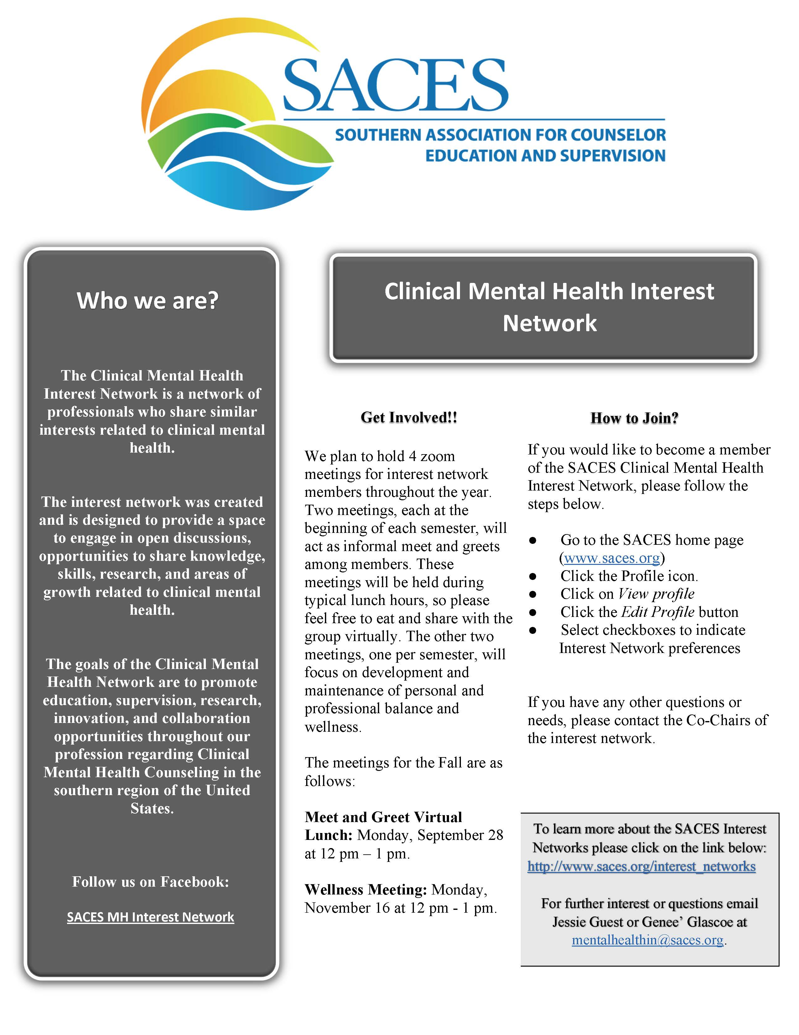Service-Learning in Counselor Education: Enhancing Personal and Professional Development through Classroom, Community and Service Connections
Karl Vonzell Mitchell, Texas A&M University – Corpus Christi

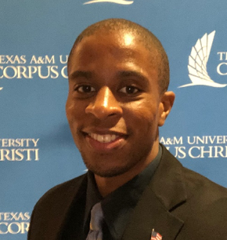
Karl Vonzell Mitchell,

Service-learning is best described by its various components and types such as civic engagement and civic learning (Midgett & Doumas, 2016). Civic engagement includes activities that benefit the community, providing purpose through addressing community needs. Civic learning involves connecting course content to community service (Midgett & Doumas, 2016). Students serve within the context of the course and community, providing structure through the integration of classroom knowledge (Midgett & Doumas, 2016). Other components include partnerships with community organizations, residents, clients and adhering to values, civic responsibility, personal/professional growth and development (Bringle et al., 2016a; Midgett & Doumas, 2016).
The different types of service-learning that can be incorporated with courses/curriculums are described in Table 1 and can be utilized quantitatively and qualitatively. Authors such as Bringle et al. (2016a), Bringle et al. (2016b) as well as Lee and Kelley-Peterson (2018) explored ways of designing, implementing, and assessing service-learning relevant to the development of social justice and advocacy competencies.

Table 1
Types of Service-Learning and Descriptions

Type of Service-Learning | Description
Direct Service-Learning | Interaction with clients or residents in the community.
Indirect Service-Learning | Indirect work that improves the community.
Research Service-Learning | Collecting, managing, and analyzing data.
Advocacy Service-Learning | Students utilize skills/course content to address social/community issue while advocating for clients and raising awareness of community issues.
Project Based Service-Learning | Students work with community organizations on projects based on community need or community defined issue.

For students, service learning provides service to the community that enables them to further their understanding of course content through applied learning (Bringle et al., 2016). For the community, partnering agencies with teachers, students, and community members can assist in helping solve issues affecting such agencies. For the society, these collaborations help formulate dynamic interactions that can lead to sustained resolve.
The collective interactions between students, the community, and society formulate the foundation of service-learning. In essence, student knowledge and skills are utilized with community service. From a counselor education standpoint, students engaged in service-learning are able to obtain experience in areas they would want to specialize in as clinicians. These student/community partnerships also improve student understanding of concepts, theory, and practice; providing avenues for personal growth, professional development, enhanced learning goals, and positive academic, personal, and civic outcomes (Arman & Scherer, 2002; Bringle et al., 2016a).
When purposefully considering each component, type, and element of service-learning, counselor educators can provide professional preparation and development, improve services to the community, and enhance quality of life (Champagne, 2006).

Service-Learning in Counselor Education

Many of the contemporary conceptualizations of service-learning have been identified to aid counselors-in-training and student development (Koch et al., 2014; Lee & Kelley-Peterson, 2018). Service-learning has also been identified to be effective in counselor education classes, such as Career Counseling, Multicultural Counseling, and Social Justice Counseling and Advocacy, where students were able to apply career counseling skills and advocate for clients and their communities (Bemak et al., 2011; Bemak & Chung, 2011; Burnett et al., 2004; Midgett & Doumas, 2016).
Service-learning has also been an important part of professional development of multicultural and social justice competencies (Bemak & Chung, 2011; Burnett et al., 2004; Midgett & Doumas, 2016). In describing service-learning in counselor training, Constantine et al. (2007) stated that it provided “students with a practical understanding of large-scale societal inequities, along with mechanisms by which they may intervene to effect change” (p. 27). Service learning offers students the opportunity to learn skills in “research, evaluation, and program development” which can be transferred, among others, to “community mental health settings” (Constantine et al., p. 21),

Service-learning benefits for counselors-in-training include personal and professional development utilizing practical experiences, cultural knowledge through immersion with different cultures and populations, advocacy by working with communities, and self-awareness through collective experiences (Koch et al., 2014). Lee and Kelley-Peterson (2018) discussed how service-learning can be an important part of student professional development by providing insights on the incorporation of service-learning in their human development course. They note that service-learning can further student understanding of systemic social inequities by advocating with and on behalf of marginalized communities. If utilized before practicum, it can provide students with more of a understanding of counselor roles (Lee & Kelley-Peterson, 2018).
Service-learning is also applicable to school counselor preparation with the integration of theory and practice in school counseling (Arman & Scherer, 2002). Applying theory to practice through service-learning has enhanced learning experiences and school counselor development by providing collaborations between university or public schools, increasing understanding of student area(s) of specialization, and increasing awareness of the school counselor role (Arman & Scherer, 2002).
Service-learning in Counselor Education has been incorporated into courses both domestically and internationally (Bemak et al., 2011; Bemak & Chung, 2011; Koch et al., 2014). Bemak et al. (2011) facilitated and implemented a Career Counseling service-learning project where students applied career counseling skills and interventions to community and school settings. These collaborations with community agencies helped in addressing community and client needs relevant to homelessness, substance abuse, working with students in alternative high schools, foster care, and those previously incarcerated (Bemak et al., 2011). Service-learning in career counseling have included work with prison populations, protection of unaccompanied children, immigrants, refugees, gang prevention, and development of social justice advocacy, and multicultural competence (Bemak & Chung, 2011).

In an international cultural immersion social justice service-learning project, findings indicated that students received professional development in multicultural and social justice counseling competencies, and professional growth experiences (Koch et al., 2014). Authors found that students learned to appreciate the universality and differences of the human experience, obtained knowledge of the country and community and those they served and the impact of poverty. Students learned the importance of teachers and cultural immersion to further understand clients and developed increased self-awareness, insight, personal growth. Post-travel, students reflected on
the populations they wanted to work with, inter-group dynamics and cohesion, as well as cultural identity. Students shared the emotional impact the project had on them and their growth in comfort, willingness to interact with other cultures, and acceptability in relationships (Koch et al., 2014).

With collective local, global, school, and community settings, service-learning has the potential to be an important part of student personal and professional development in Counselor Education. From theory and knowledge to skill and competency acquisition, service-learning provides meaningful classroom, community, and service connections.

References
Arman, J. F., & Scherer, D. (2002). Service learning in school counselor preparation: A qualitative analysis. Journal of Humanistic Counseling, Education and Development, 41(1), 69.
Bemak, F., Talleyrand, R. M., Jones, H., & Daquin, J. (2011). Implementing multicultural social justice strategies in counselor education training programs. Journal for Social Action in Counseling & Psychology, 3(1), 29-43. https://doi:10.33043/JSACP.3.1.29-43
Bemak, F., & Chung, R. C. (2011). Applications in social justice counselor training: Classroom without walls. The Journal of Humanistic Counseling, 50(2), 204.
Bringle, R. G., Reeb, R. N., Brown, M. A., & Ruiz, A. I. (2016a). Introduction. Service learning in psychology: Enhancing undergraduate education for the public good (pp. 3-17, Chapter xi, 257 Pages) APA, American Psychological Association, Washington, DC. https://doi.org/10.1037/14803-001
Bringle, R. G., Reeb, R. N., Brown, M. A., & Ruiz, A. I. (2016b). Designing a service-learning course. Service learning in psychology: Enhancing undergraduate education for the public good (pp. 55-81, Chapter xi, 257 Pages) APA, American Psychological Association, Washington, DC. https://doi.org/10.1037/14803-004
Bringle, R. G., Ruiz, A. I., Brown, M. A., & Reeb, R. N. (2016). Enhancing the psychology curriculum through service learning. Psychology Learning & Teaching, 15(3), 294-309. https://doi:10.1177/1475725716659966
Burnett, J. A., Hamel, D., & Long, L. L. (2004). Service learning in graduate counselor education: Developing multicultural counseling competency. Journal of Multicultural Counseling and Development, 32(3), 180-191. https://doi:10.1002/j.2161-1912.2004.tb00370.x
Champagne, N. (2006). Service learning: Its origin, evolution, and connection to health education. American Journal of Health Education, 37(2), 97-102. https://doi:10.1080/19325037.2006.10598885
Constantine, M. G., Hage, S. M., Kindaichi, M. M., & Bryant, R. M. (2007). Social justice and multicultural issues: Implications for the practice and training of counselors and counseling psychologists. Journal of Counseling & Development, 85(1), 24-29. https://doi:10.1002/j.1556-6678.2007.tb00440.x
Koch, J. M., Ross, J. B., Wendell, J., & Aleksandrova-Howell, M. (2014). Results of immersion service-learning activism with peers: Anticipated and surprising. The Counseling Psychologist, 42 (8), 1215-1246. doi: 10.1177/0011000014535955
Lee, K. A., & Kelley-Petersen, D. J. (2018). Service learning in human development: Promoting Social Justice Perspectives in Counseling
The Professional Counselor, 8(2), 146-158. https://doi:10.15241/kal.8.2.146

Midgett, A., & Doumas, D. M. (2016). Evaluation of Service‐Learning‐Infused courses with refugee families. Journal of Multicultural Counseling and Development, 44(2), 118-134. https://doi:10.1002/jmcd.1204,
Warter, E. H., & Grossman, J. M. (2002). An
application of developmental-contextualism to service-learning. In A. Furco & S. H. Billig (Eds.), Service-learning: The essence of the pedagogy (pp. 83–102). Greenwich, CT: Information Age Publishing.

The Graduate Student and New Professionals Interest Network

The Graduate Student and New Professionals interest network is here to connect and support graduate students and new professionals as the Fall 2020 semester arrives. We are planning to hold a meeting mid-September, be on the lookout for more details soon! Questions? Contact us at gradstudent.newprofessionalsin@saces.org
This Photo by Unknown Author is licensed under CC BY-SA-NC

Fall 2020 Newsletter Submission
Dear Counselors, Counselor Educators, Supervisors, and Graduate Students,

We are looking for submissions for consideration in our Fall 2020 issue of the SACES Newsletter. This issue will be an edition about Education - foster best practices in teaching and professional development

Submissions must be between 500 and 800 words and sent electronically as a Word document to sacesnewsletter@gmail.com. Please include the author name(s), credentials, affiliation(s), and photo(s) in .jpg, .tif or .gif format.

Students are encouraged to contribute with the support of a faculty member. For questions or more information, please contact the editors at newsletter@saces.org. You can also check out previous newsletter issues available from the SACES website. Contributions are needed by Monday, October 26th.

Andrea Kirk- Jenkins and Isabel Farrell
Co-Editors SACES Newsletter

Cohort Support and Professional Identity Development for First-Year Doctoral Students during
Shelby K. Gonzales, Ed.S, NCC, Thomas Toomey, M.S., CRC, NCC, and Olivia J. Lewis, M.A., LPC-A, The University of South Carolina.

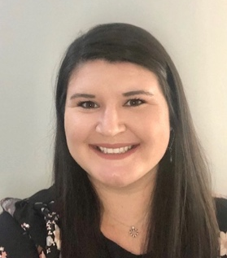
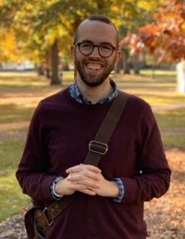
Shelby K. Gonzales (Left),
Thomas Toomey (Middle), and Olivia J. Lewis, M.A (Right)

The professional identity development of counselor educators begins during their doctoral preparation program (Calley & Hawley, 2008; Carlson, et al., 2006). Within the first year of counselor education doctoral programs, faculty have honest and frequent conversations about the major roles of a counselor educator (i.e., teacher, researcher, supervisor, service) and what the professional identity development processes may look like. Limberg et al. (2013) described experiential learning opportunities (e.g., teaching, participating on research teams, supervising students) as being crucial to professional identity development of counselor education doctoral students within a doctoral preparation cohort model. For many, COVID-19 shifted expectations for the first year in a doctoral program. Specifically, many face-to-face experiential learning opportunities moved to an online format, disrupting expectations for identity development milestones (Limberg et al, 2013; Protivnak & Foss, 2009).
In their first year, doctoral students learn how to adopt the complex professional identity roles found in counselor education for the first time. COVID-19 required a transition to online learning and shifted expectations as to how growth as counselor educators would occur. Faculty in many programs had to focus on programmatic and administrative concerns (e.g., requirements for CACREP accreditation and graduation) while continuing to mentor students virtually. Conferences and networking opportunities were canceled, opportunities to supervise students were replaced with more feasible in-class practice and role-plays, and learning to teach online was an additional skill that doctoral students had to acquire while learning how to become counselor educators.
Doctoral cohort models provide communities of support that can become safe havens through the major developmental milestones of the doctoral program (Protivnak & Foss, 2009). Protivnak and Foss (2009) examined the experiences of counselor education doctoral students and found that doctoral students rely on each other as primary social supports throughout their program. The themes identified as helpful by Protivnak and Foss (2009) are important to consider when examining the experiences of counselor education doctoral students navigating their doctoral programs during COVID-19. While navigating the latter half of the spring semester during the pandemic, having supportive cohort members to lean on becomes imperative for not only practical reasons (e.g., staying accountable for deadlines) but also for emotional support and coping with the new stressors of the changing learning environment. Translating in-person social supports to online video calls can allow space for care and support for how each individual is coping. In addition to cohort members, program members in another year’s cohort (i.e. 2nd, 3rd, and 4th-year students) play a role in the network and community of support for first-year doctoral students (Protivnak & Foss, 2009). Increasing connectedness online allows for alternative ways to connect in the new normal.
Being a doctoral student during COVID-19 brought unique challenges and opportunities for growth that differed from the normative counselor educator professional identity development processes studied by previous scholars. As the fall 2020 semester approaches, there is still some uncertainty about how experiential learning opportunities will be modified, and what that will mean for the development as counselor educators and leaders within the profession. Researchers have a unique opportunity to closely examine the impact of online learning and virtual cohort support in counselor educators’ professional identity development.

References
Calley, N. G., & Hawley, L. D. (2008). The professional identity of counselor educators. The Clinical Supervisor, 27, 3–16.
Carlson, L. A., Portman, T. A., & Bartlett, J. R. (2006). Self-management of career development: Intentionally for counselor educators in training. Journal of Humanistic Counseling, Education and Development, 45, 126–137.
Limberg, D., Bell, H., Super, J. T., Jacobson, L., Fox, J., DePue, K. M, Christmas, C., Young, M. E., & Lambie, G. W. (2013). Professional identity development of counselor education doctoral students: A qualitative investigation. The Professional Counselor, 3(1), 40-53.
Protivnak, J. J., & Foss, L. L. (2009). An exploration of themes that influence the counselor education doctoral student experience. Counselor Education and Supervision, 48(4), 239-256. Doi: 10.1002/j.1556-6978.2009.tb00078.x

Distance/Online Learning IN

We would like to invite you to the Distance/Online Learning IN Coffee Chats! All members are welcome to attend.
September 2, 2020 @ 09 AM EST
Focus will be on practicum/internship in an online/virtual format.
Register in advance for this meeting URL
October 7, 2020 @ 10 am EST
Click here for the Registration URL
December 2, 2020 @ 10 am EST
Click here for the Registration URL
January 6, 2021 @ 10 am EST
Click here for the Registration URL
Hosted by Dr. Summer Kuba & Dr. Ellen Chance, Co-Chairs of the Distance/Online Interest Network
March 3, 2021 @ 10 am EST
Click here for the Registration URL
May 5, 2021 @ 10 am EST
Click here for the Registration URL
Social Justice and Human Rights Interest Network
Who are we: The Social Justice and Human Rights Interest Network (SJ+HR IN) is a network of counselors, counselor educators, and supervisors who share an interest and commitment to social justice and human rights within the counseling profession. Our goal is to connect SACES members and to provide room to understand and engage in the liberation of underserved communities within the Southern Region. We hope to provide a space for professionals to meet, to collaborate, and to take action towards creating a more inclusive and just society.
What is our theme: This year, SJ+HR IN’s theme is twofold: Community Awareness and Coalition Reinforcement. If you want to know more about what that means, come to our Fall Members meeting in October!
Who is invited to the table: Everyone! All active members of SACES who share our passion and commitment for justice are invited to participate in our interest network
We plan to have 3 meetings (one per semester) with SJ+HR IN members to accomplish our goals for the upcoming year. Our virtual Fall 2020 meeting will be held via Zoom on Tuesday, October 13 at 11:00am ET/10:00am CT. In order to receive our meeting Zoom link, make sure you are an active member of the SJ+HR Interest Network.
How to sign up: If you would like to become a member of the SACES Social Justice and Human Rights Interest Network, please follow the steps below:
- Go to the SACES home page (www.saces.org)
- Sign in
- Click the Profile icon.
- Click on View profile
- Click the Edit Profile button
- Select checkboxes to indicate Interest Network preferences
If you are excited about learning more or have any questions, feel free to contact Dr. Marlon Johnson or Dr. Mickey White, SJ+HR IN Co-Chairs at socialjusticein@saces.org
Let’s get ready to do great work this year!
-SJ+HR IN

